

Project Report

Cloud Computing Mini Project  
  
  
  
Topic : Deploy Static Website On AWS  
  
  
  
Submitted By :

Tejas Desai (21CO036)  
Aniket Bidgar (21CO026)  
Mayank Diwate (21CO040)  
Anurag Deshmukh (21CO037)

Guide : Mr. N. R. Talhar Sir

ABOUT THE PROJECT:

Our project is a versatile text editor built with HTML, CSS, and JavaScript, designed to cater to a wide range of users. One of its standout features is voice typing, which allows users to dictate text directly into the editor, making it easy for those who prefer speaking over typing.

In addition to voice typing, the editor supports a variety of formatting options. Users can transform text to uppercase or lowercase with a single click and justify text to align left, right, centre, or fully justified. These features help users create professional and organized documents.

The real-time preview option provides instant feedback, showing how the text will look when finalized. Users can also download their edited text in various formats, enabling easy sharing and offline use.

Furthermore, our text editor includes a text-to-speech function, allowing the editor to read content aloud. This feature is beneficial for visually impaired users and those who like to listen to their text to spot errors or inconsistencies. With these capabilities, our project is an all-in-one text editor solution.

ABSTRACT:

This abstract outlines the process of deploying a static website on Amazon Web Services (AWS) Elastic Compute Cloud (EC2), a scalable and customizable virtual server solution. A static website, composed of HTML, CSS, JavaScript, and other client-side assets, offers a straightforward and cost-effective way to present information online. Leveraging AWS EC2 instances allows users to have full control over their hosting environment, enabling customization and scalability according to their specific requirements.  
  
Key steps in deploying a static website on AWS EC2 include launching an EC2 instance, installing and configuring a web server software such as Apache or Nginx, uploading website files to the server, and configuring security settings and domain associations. Additionally, users can implement monitoring, backup, and disaster recovery measures to ensure the website's reliability and availability.

## INTRODUCTION:

Deploying a static website on Amazon Web Services (AWS) offers a robust and scalable solution for hosting web content without the need for complex server configurations. In recent years, the popularity of static websites has surged due to their simplicity, security, and cost-effectiveness. AWS, as a leading cloud computing platform, provides a suite of services that streamline the deployment process, making it accessible to both beginners and experienced developers.

This introduction sets the stage for understanding the fundamental steps involved in deploying a static website on AWS. We'll explore the benefits of static websites, outline the key AWS services involved, and provide an overview of the deployment process. Whether you're a seasoned developer looking to leverage AWS for hosting or a newcomer interested in learning cloud deployment techniques, this guide will equip you with the knowledge and skills needed to launch your static website on AWS with confidence.

Cloud Computing:

Cloud computing is a term that refers to the delivery of computing resources and services over the internet, including storage, software, and processing power. It provides users with a flexible and scalable infrastructure without the need to invest in expensive hardware and software.

Cloud computing offers several benefits, including:

1. Scalability: Cloud computing enables users to scale their infrastructure up or down based on demand. Additional resources can be allocated dynamically as the workload increases, ensuring that applications can handle sudden spikes in traffic without manual intervention.
2. Cost-effectiveness: Cloud computing can be more cost-effective than traditional IT infrastructure, as users only pay for the resources they use. Cloud providers offer a range of pricing models, including pay-as-you-go, subscription-based, and reserved instances.
3. Accessibility: Cloud computing services can be accessed from anywhere with an internet connection, enabling users to work from anywhere in the world. This makes it easy for distributed teams to collaborate and share resources.
4. Security: Cloud providers invest heavily in security and offer a range of security features, including data encryption, firewalls, and identity and access management. They also comply with industry standards and regulations, ensuring that data is secure and compliant.

Cloud computing involves the use of remote servers on the internet to store, manage, and process data. Cloud computing providers such as Amazon Web Services, Microsoft Azure, and Google Cloud Platform offer various services, including virtual machines, storage, databases, and serverless computing.

# Amazon Web Services(AWS):

Amazon Web Services (AWS) is a comprehensive and widely-used cloud computing platform offered by Amazon.com. Launched in 2006, AWS provides a vast array of cloud services, including computing power, storage solutions, networking capabilities, databases, machine learning tools, and more. These services are designed to help businesses and individuals build, deploy, and manage a wide range of applications and workloads with ease and scalability.

Key Features and Services:

* Compute: AWS offers various compute services, including Amazon Elastic Compute Cloud (EC2) for scalable virtual servers, AWS Lambda for serverless computing, and AWS Batch for batch processing workloads.
* Storage: AWS provides scalable and durable storage options, such as Amazon Simple Storage Service (S3) for object storage, Amazon Elastic Block Store (EBS) for block storage volumes, and Amazon Glacier for long-term archival storage.
* Databases: AWS offers a range of database services, including Amazon Relational Database Service (RDS) for managed relational databases, Amazon DynamoDB for NoSQL databases, and Amazon Redshift for data warehousing.
* Networking: AWS provides networking services such as Amazon Virtual Private Cloud (VPC) for isolated virtual networks, Amazon Route 53 for domain name system (DNS) management, and AWS Direct Connect for dedicated network connections.
* Machine Learning: AWS offers machine learning services like Amazon Sage Maker for building, training, and deploying machine learning models, Amazon Recognition for image and video analysis, and Amazon Comprehend for natural language processing.
* Security and Identity: AWS provides security services including AWS Identity and Access Management (IAM) for managing user access and permissions, AWS Key Management Service (KMS) for encryption key management, and AWS WAF for web application firewall protection.

Deploying a static gym website on AWS, we need to follow the steps below:

1. Launch an EC2 Instance:  
   Log in to the AWS Management Console and navigate to the EC2 service.  
   Click on "Launch Instance" and select an Amazon Machine Image (AMI), such as Amazon Linux or Ubuntu, suitable for your web server.  
   Choose an instance type, configure instance details, add storage as needed, configure security groups to allow HTTP (port 80) and HTTPS (port 443) traffic, and review and launch the instance.
2. Connect to the Instance:  
   Once the instance is running, connect to it using SSH (Secure Shell) from your local machine or via the AWS Management Console's browser-based SSH client.
3. Install Web Server Software:

Update the package repository and install a web server software such as Apache HTTP Server or Nginx. For example, on Amazon Linux, you can use:

sudo yum update -y

sudo yum install httpd -y

sudo systemctl start httpd

sudo systemctl enable httpd

1. Upload Website Files:  
   Transfer your website files (HTML, CSS, JavaScript, images, etc.) to the appropriate directory on the EC2 instance. Typically, web files are placed in the /var/www/html/ directory for Apache.
2. Configure Security Settings:  
   Set appropriate permissions on the website files to ensure they are readable by the web server user. Optionally, configure SSL/TLS certificates for HTTPS encryption. You can obtain certificates from a certificate authority or use Let's Encrypt.
3. Test the Website:  
   Open a web browser and enter the public IP address or public DNS of your EC2 instance to test the website. Ensure all pages render correctly and assets load properly.
4. Backup and Disaster Recovery:  
   Implement backup and disaster recovery strategies to ensure the website's data is protected. You can use Amazon EBS snapshots for data backup and create AMI backups for the EC2 instance configuration.
5. Regular Maintenance and Updates:  
   Perform regular maintenance tasks such as applying security updates, monitoring server logs for errors, and optimizing server performance.

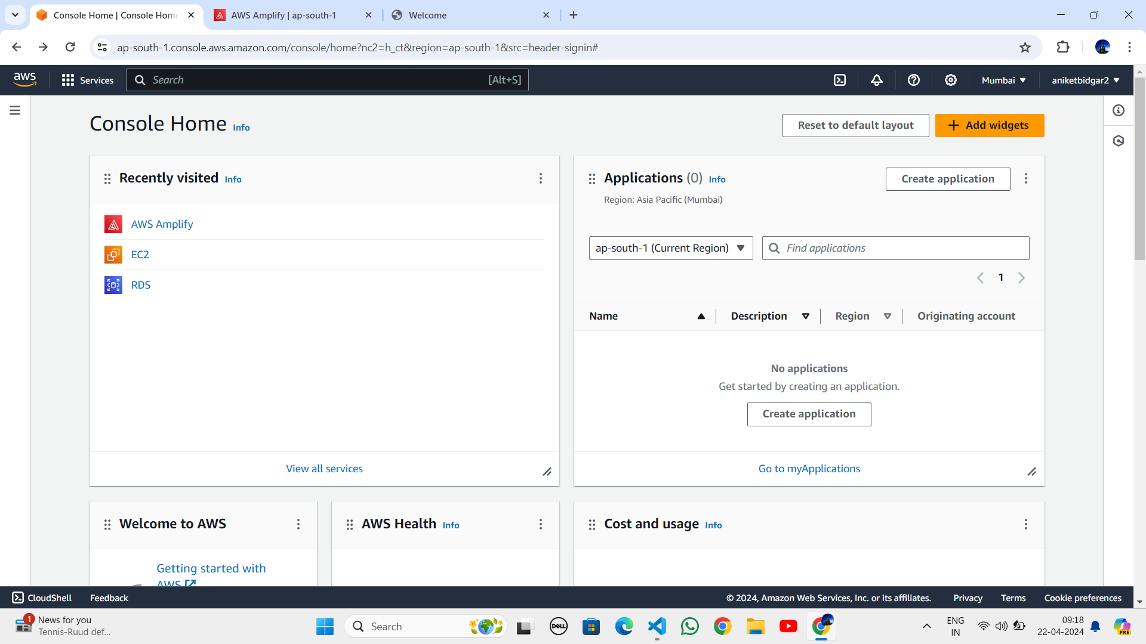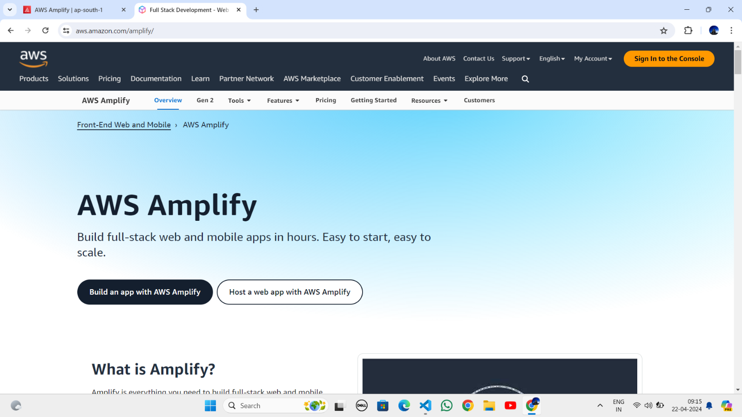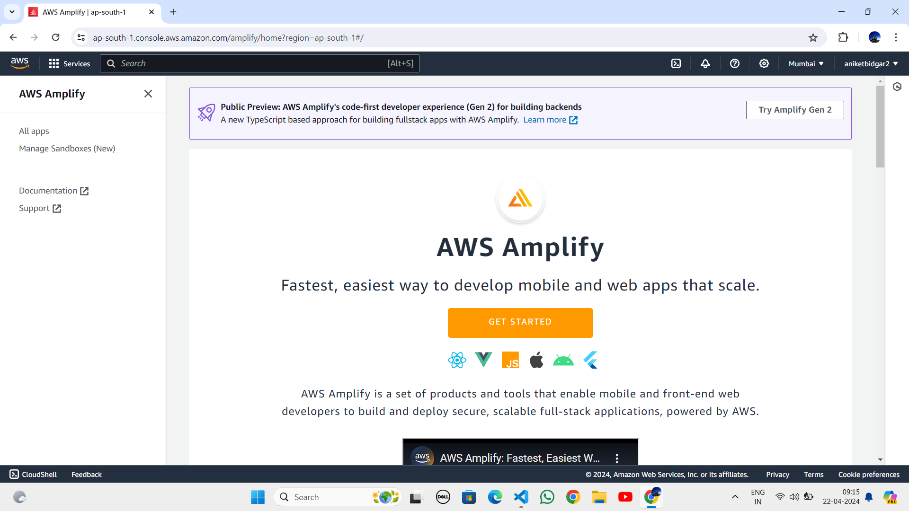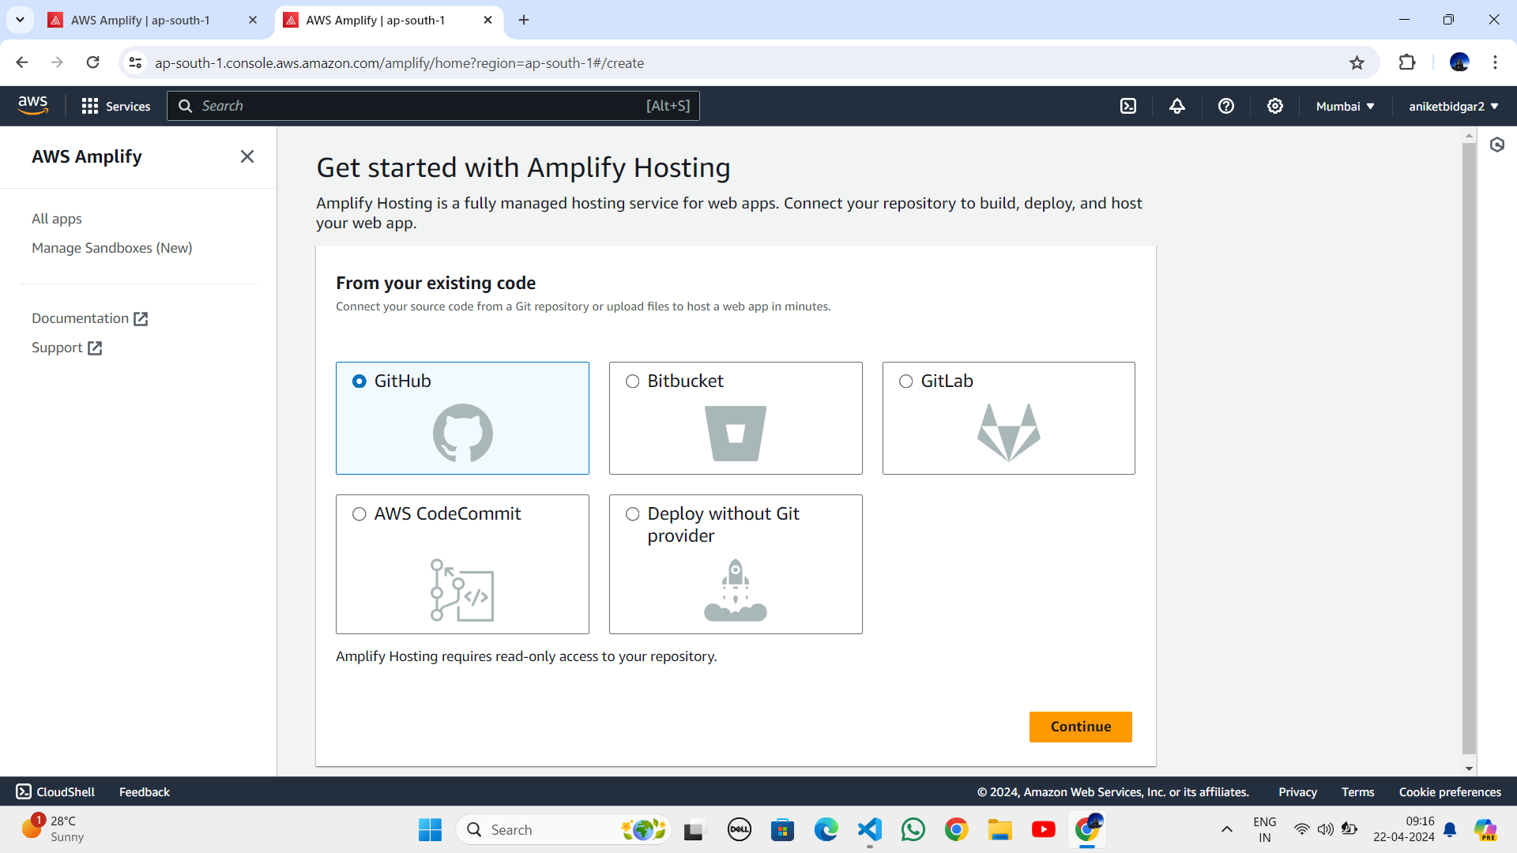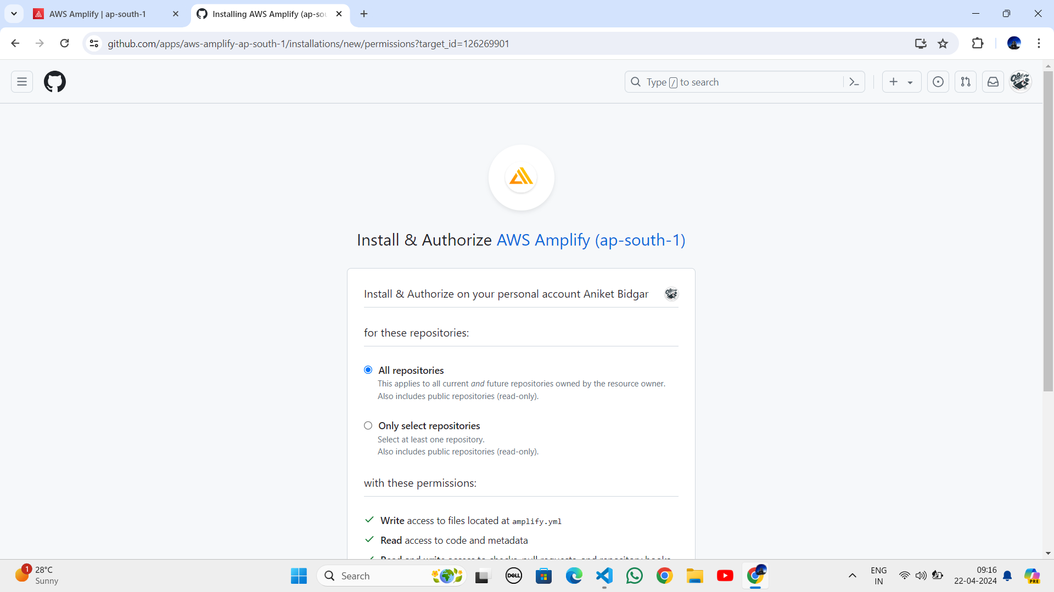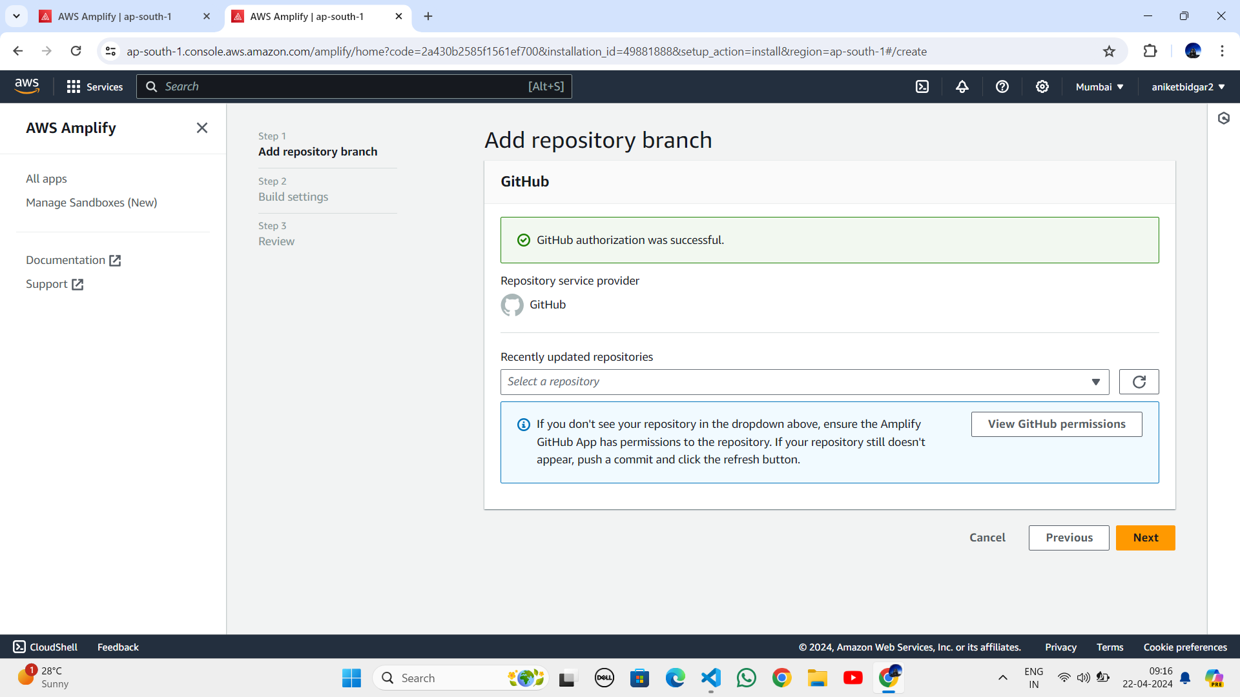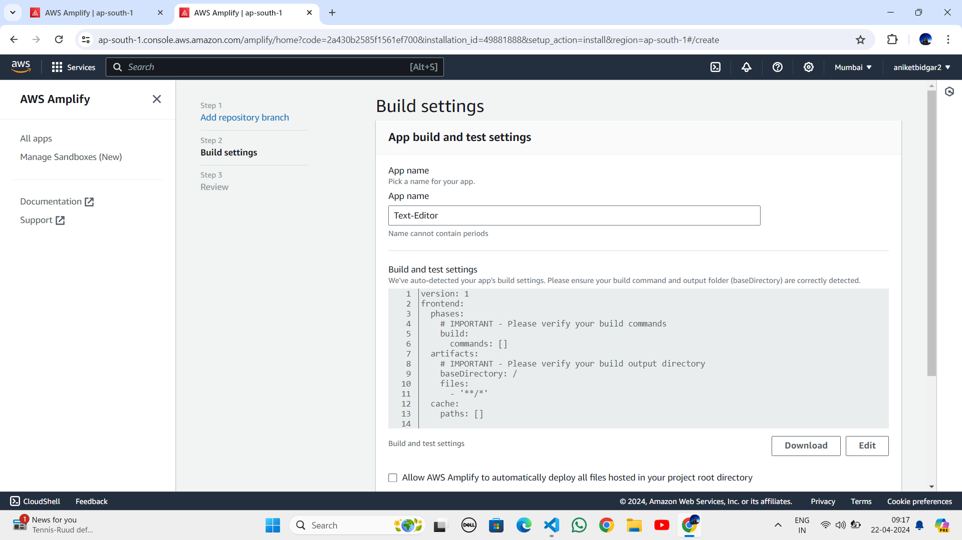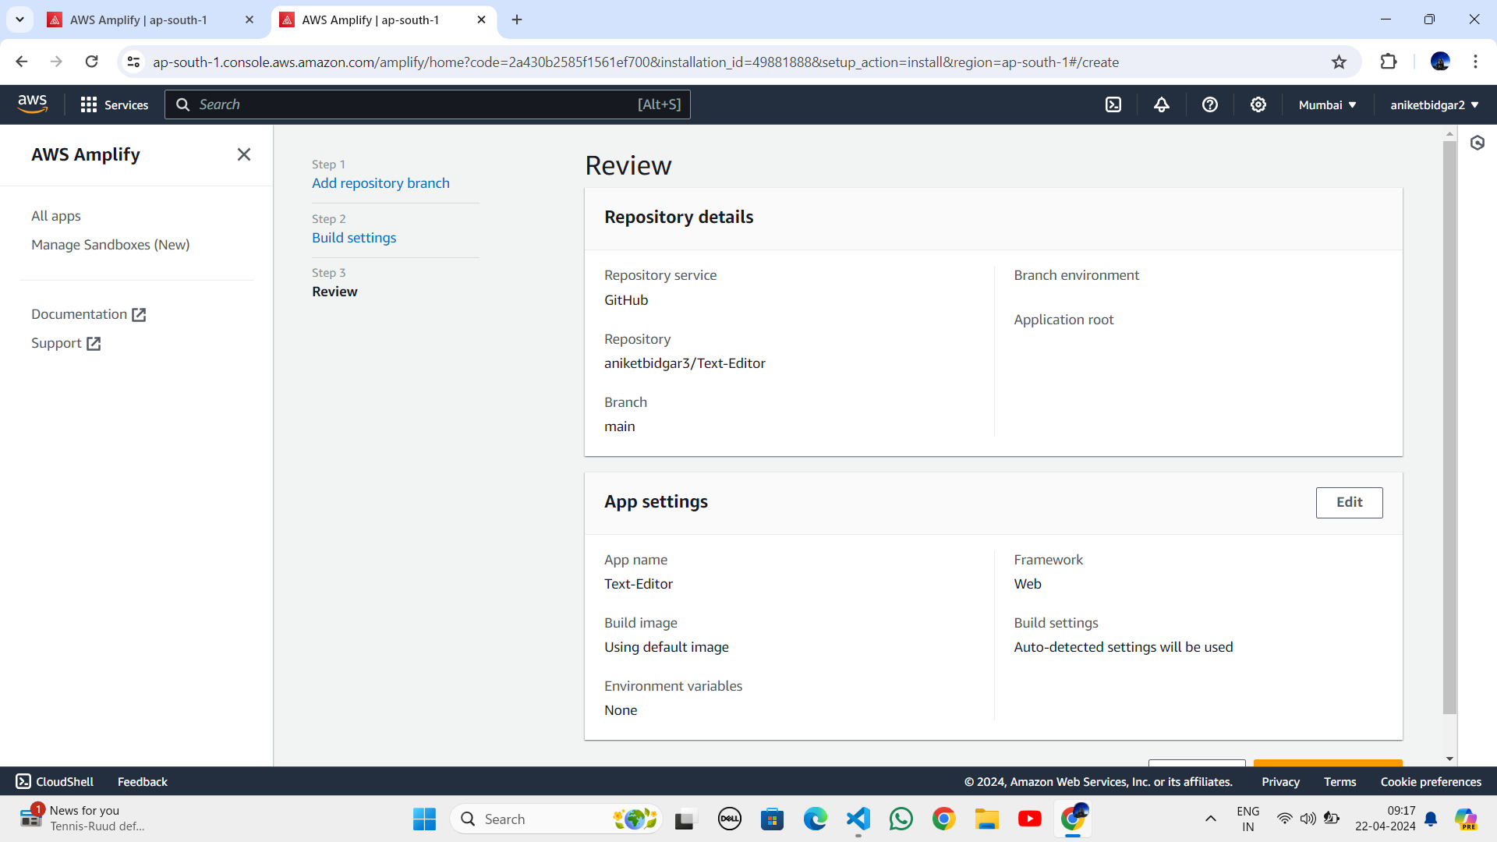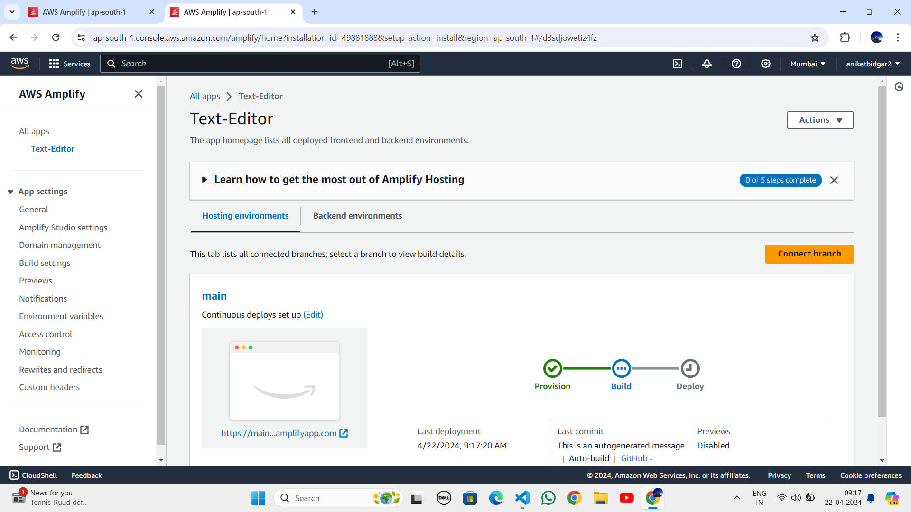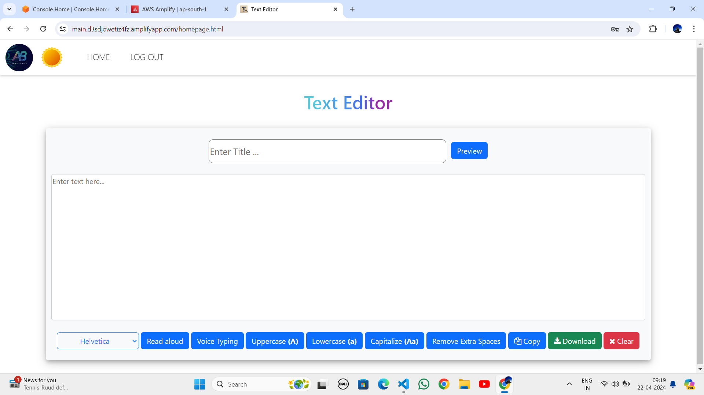

CONCLUSION:

In conclusion, Deploying a static website on Amazon Web Services (AWS) offers a straightforward and efficient solution for hosting web content in the cloud. Throughout this guide, we've explored the benefits of static websites, including their simplicity, security, and cost-effectiveness. With AWS, websites can handle varying levels of traffic seamlessly, ensuring a smooth user experience even during periods of high demand. Additionally, AWS's pay-as-you-go pricing model means users only pay for the resources they use, making it a cost-effective solution for hosting projects of all sizes. Whether you're launching a personal blog, a portfolio site, or a small business website, AWS empowers you to bring your web projects to life quickly and efficiently. With its robust infrastructure and flexible pricing options, AWS remains a top choice for hosting static websites in today's digital lands